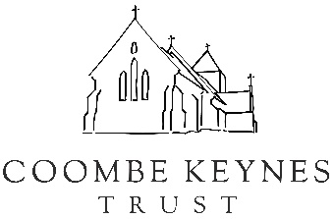
Personal History Prompt
Thank you for taking the time to help us with the Coombe Keynes History Project.
As you get started, please remember:
- This document is just a guide to help you tell us your story
- Don’t feel daunted by all the questions; be as fulsome or brief as you like and feel free to skip sections entirely
- Some of your answers might naturally overlap between questions; don’t feel the need to repeat yourself
- Any story, however, seemingly insignificant is welcome: often personal anecdotes are the most powerful way of preserving the village’s collective memory
Thank you!
Email your answers to history@coombekeynes.com

- What is your connection to Coombe Keynes?

- What dates did you live in / visit Coombe Keynes? (approximate is fine)

- Where did you live/stay? What can you remember about the house?

- What brought you to the village?

- What were your earliest memories/ first impressions of the village?

- Tell us about any interesting residents of Coombe Keynes during your time here. What were their roles in the village and what was your relationship with them?

- Did you see the village change during the time you were there? (Think of both the buildings and the people.)

- Do you recall any memorable events taking place while you were in the village? (eg village fetes, Jubilee celebrations, extreme weather or external events eg the Moon Landings or power cuts in 1970s, the Pandemic)

- Are there any other anecdotes about your time in the village you’d like to share?

- If you are no longer in the village, why did you leave?

- Is there anyone else you think we should send this survey too? If so, would you be happy to share their details (or pass it on yourself)

- Are you happy for us to publish this information online as part of the Coombe Keynes History Project? Or would you prefer we keep it in on file until a certain date? If so, when? (Please feel free to make notes as you go if there are some parts you’re happy to share and some bits that might need to wait 20 years!)

